AK STATE ORGANIZATION 1
New State Officers 1
Summer Conferences 1
Mini Project Award 2
Chapter Presidents 3

ACTION ITEMS
- International Convention --
Portland, OR July 7-10
San Antonio, TX July 21-24

- Click here to get PDF of this newsletter to print

AK STATE ORGANIZATION
New officers were elected at our Spring 2021 Virtual conference.
Congratulations to:
President, Gara Williams (Epsilon)
1st Vice President, Amy Budge (Omicron)
2nd Vice President, Jessica Minguez (Zeta)
Secretary, Gretchen Klein (Epsilon)
Treasurer, Joan Lower (Eta)

DKG Summer Conferences
Click on the link for more information

Portland, OR - July 7-10

San Antonio, TX July 22-24

Tampere, Finland - has been postponed until 2023

Mini Project Award Opportunity

Delta Kappa Gamma Chapters in Anchorage are offering teachers an opportunity to apply for a $250 grant to support classroom projects. Application proposals must include the name or names of all teachers and schools involved. Teachers, teaching teams or faculty groups may submit one proposal. The teacher submitting the application must include a summer home address, home e-mail and home or cell phone number.

Please attach a 1-2 page, double-spaced description of your proposal. Illustrations may be included.

The proposal should include a description of the project to include its specific learning goals, a timeline for implementation in the 2021-2022 school year, the number of students impacted, and a projected budget listing how the grant funds will be used. The expenditures must be for items not provided by regular school funds.

Proposals will be evaluated using the following criteria:
Creativity/Originality /Uniqueness
Sustainability (Will this grant fund one year, more or be ongoing?)
Reproducible (Could this be a pilot project that others might adopt?)
Number of teachers involved
Number of students impacted

Your acceptance of this DKG grant requires you to attend a hosted Delta Kappa Gamma Mini-Grant breakfast on October 9, 2021 where you will be invited to make a short presentation describing your project and its expected outcomes.

Proposals should be sent as an attachment via email by August 1, 2021 to Jennifer Schmitz at jcschmitz@yahoo.com
Grantees will be notified by May 15, 2021
Four $250.00 Mini-Grants will be awarded in 2021
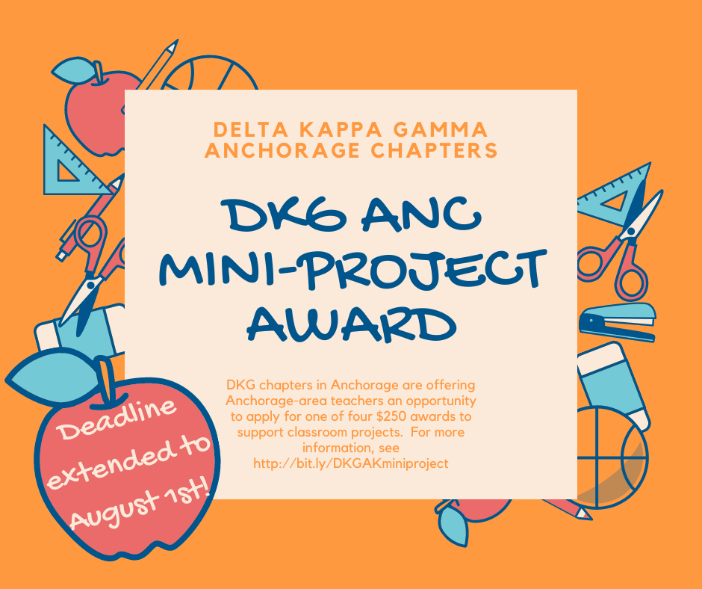
. | Alaska State Organization  The Delta Kappa Gamma Society International  NOT Beta Gamma State  ​At the International Convention of Delta Kappa Gamma in 2018, the convention voted to change the name of each of our states. This change removed the Greek letters from all states. Our new name, Alaska State Organization was inserted in our Bylaws and Standing Rules in 2018.  Our Bylaws Article I, Name, Section A. states: The name of this state organization shall be Alaska State Organization, The Delta Kappa Gamma Society International, hereafter known as DKG Alaska.  (Individual chapters will continue to be named by a Greek letter and city location.)  As an organization we need to remove the words Beta Gamma State from all of our forms and documents. The exceptions are documents which are a part of our historical record.  Headings for our forms and documents should be listed as above. The shortened name,DKG Alaska, may be used in the body of documents and correspondence. We all need to work together to remember to use our new name.  If you see the use of Beta Gamma State in any documents, please remind the person who sent you the document of the name change or notify the Rules Committee.  Barbara Sell  Rules Chair  April, 2020  Want more information about DKG ALASKA?  Check out our website!  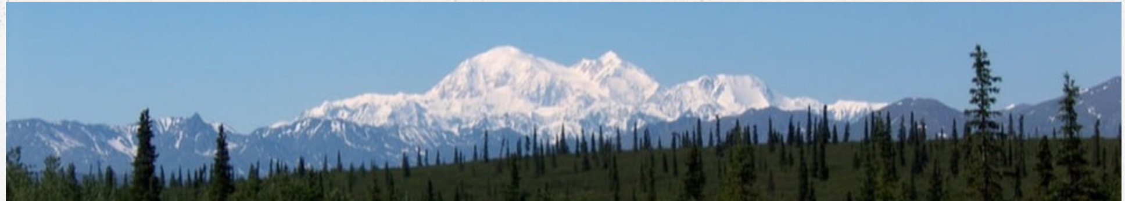  Alaska Chapter Presidents 2020-2022 ﻿  Beta - Fairbanks - Eleanor Houts  eleanorhouts@gmail.com  Epsilon - Ketchikan - Peaches Wallin borninabus@hotmail.com  Eta - Anchorage - Karen Wallace  kwallace@gci.net  ​Iota - Sitka - Marcia Hirai  marciahirai@gmail.com  Nu - Eagle River - Helen Harmon harmon_helen@asdk12.org  Omicron - Homer - Amy Budge  abudge@xyz.net  Theta - Fairbanks - Aldean Kilbourn akilbourn@gci.net  ﻿Zeta﻿ - Anchorage - Jessica Minguez and Nicole Ullman jessica.albarran@gmail.com ullman_nicole@asdk12.org

