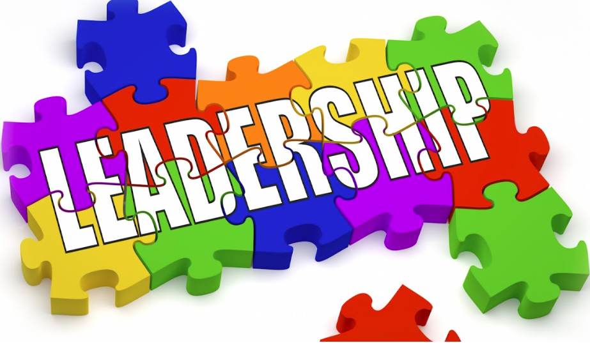
Leadership Committee Report
4-27-19

Committee Members:
Daphne Hofschulte, Chair
Vicky Foley, Membership
Gayle Hammons, EEC/Program
A chapter or a state
can’t have good “followership” without good “leadership”!

Joan Lower, Treasurer
Cherilyn Ansley, Secretary – supporting member
Colleen Brown, President, ex officio

Actions:
* Proposed $3000 in the 2019-2020 biennium budget for stipends for leadership training. (Presumably for the 2020 Leadership Convention in Ketchikan.) -- Approved by Ex Bd 4-9-19

* Research survey for leadership involvement on the part of new Alaska DKG members:

Hello, Sisters,

DKG has strength in numbers! You are part of the group of 60 "new" members that have joined DKG Alaska in the last 5 years. We are so glad to have you!

Please help us think about “leadership” by answering 2 questions?
(1) What leadership positions have you taken on since you joined - at either chapter or state level? They could be as a committee chair, officer, project coordinator, etc. If none, you can just say "none."

(2a) If your response is "none," would you please share some reasons why you haven't yet? They could be "no time," "haven't been asked," "don't feel ready," or whatever.

(2b) If you have taken on leadership positions, please share how you came to accept those roles. It could be you volunteered, someone else volunteered you, you were elected, etc.
This information all will be statistical with no names attached. If I don't hear from you by this weekend, I'll try to give you a quick call to touch base.
Thank you for your time and information. We hope to "see" you online in April!
Daphne Hofschulte
DKG Alaska Leadership Chair
machof@hotmail.com

Email survey: 2 responses
Followup by phone with 25 of the remaining 58: 17 contacts, 11 responses

Most new members who responded ARE involved in their chapters. Two are involved at the state level. Those not involved cited teaching or family circumstances. One had not been asked.

Remaining Responsibilities:
Schedule, plan and facilitate an orientation with outgoing and newly elected state officers.

